BHD Syndrome International Registry (BIRT) User Guide

Version 0.1 [H20]
April 4, 2022
Pulse Infoframe Inc.

Table of Contents
2 INTRODUCTION 3
3 PATIENT REGISTRATION 3
3.1 REGISTERING 3
3.2 EMAIL TO ACTIVATE ACCOUNT 4
3.3 FORGOTTEN PASSWORD 4
3.4 EMAIL PROMPTS 4
4 Consent information 4
4.1 CONSENT 4
4.2 ASSENT 5
5 My Profile 6
6 Dashboard 7
6.1 Overview 7
6.2 Message Center bar 7
6.3 SURVEYS 7
6.4 MY LIBRARY 8
6.5 MY PROFILE 8
6.5 a Identity Details 8
6.5 b My Consent 8
6.5 c Withdrawing Consent 8
6.6 LOGGING OUT 9
7 Help 9

INTRODUCTION
Thank you for your interest in the BHD Syndrome International Registry (BIRT). This registry will follow participants over time. The aim of this web-based registry is to collect information that is relevant to the individual and to their condition. The information will include personal, medical, and health care resource information about patients with Birt-Hogg-Dubé Syndrome (BHD) in order to improve both our understanding of the disease (e.g., long-term trends in a specific patient group) and to help inform the provision of future care for patients. The sort of real-world data collected in this registry can also help to better understand the impact of BHD patients and support health care policy and funding decisions. Researchers may also use this registry to design and conduct research, as well as to identify patients who may be eligible for participation in future research studies (if you choose to be contacted). We hope to recruit patients with BHD into our registry to obtain insights about how to better manage characterize this disease, its progression and treatment.
The purpose of this document is to provide an overview of the registry. Each section will briefly describe the workflow and registry features.

PATIENT REGISTRATION

REGISTERING
On the registration page you may Register for the first time or Login if you already have an account. When signing up for the first time, enter your name and email address and respond to any other questions. Check the “I’m not a robot” box and click SUBMIT.

EMAIL TO ACTIVATE ACCOUNT
Once you have registered, you will receive a Welcome email which will give directions to activate your account and will provide an overview of the next steps. Within the email message there is an “Activate your account” option—Click on that button. Once you have selected the Activate button from your email, an activation page will appear. Your User Name is your email address that you provided earlier. Here you will be asked to create and confirm your password. The password requirements are as follows: minimum of 8 characters, including 1 upper case letter, 1 lower case letter, 1 number and 1 special character. Upon completion select “Get Started”.

FORGOTTEN PASSWORD
If you need to reset your password, go to the Sign-in page and click on the “Did you forget your password?’ link to reset your password. Provide your email address that you used to register and an email will be sent with instructions:

EMAIL PROMPTS
As a registered participant in of this registry, you will receive email prompts to remind you to complete certain steps required in order to be actively engaged in participating in the registry. You will receive emails to activate your account, sign the consent, and enter your information in the patient profile along with completing surveys.

ACTIVATION EMAIL
When you select Activate Your Account in your activation email, a screen will appear a asking you to provide some basic information which is described in section 4. Once you have completed the required information and you choose to “FINISH” you will be presented with the Informed Consent Form.

Consent information

CONSENT
As a participant, you will be presented an electronic informed consent form (ICF) on the patient portal. The ICF provides participants with information about the purpose of the research and the privacy and use of your submitted data so participants can make an informed decision about their participation in the registry. By signing the electronic consent, participants are agreeing to the collection of personal health information and use of their data by appropriate research entities described in the consent in a de-identified format with adherence to Institutional Review Board (IRB), GDPR and HIPAA requirements. If you choose to sign the consent, you are selecting to opt in and will be agreeing to participate in survey collection. If you decide to decline or opt out, you will no longer be asked to complete surveys and no further information will be collected.
Please read through the consent thoroughly and ensure you fully understand the purpose of the registry and what you are being asked to do.
To register on behalf of a child under the age of 18, you will be asked to sign the electronic informed consent form as the “Parent/Guardian”. If the child is between age 10-17, a second “Assent Form” will be displayed after the informed consent form is signed and submitted.
If you are comfortable and ready to proceed, use the DocuSign function, which is a secure way to electronically sign and provide your consent to participate in the registry. Check the box with the statement, “I agree to use electronic records and signatures”. Once that box is checked, the CONTINUE button will become active:
When the consent form appears, please read the instructions carefully. Click the agree to use electronic signature box in the upper left of the screen. If you click “Other Actions”, these are options from which you may choose:

If you select the CONTINUE option, this full consent form will appear. Select the START button. Please read all of the information thoroughly! If you have any questions there is contact information in the text of the document.
When you reach the bottom of the document you will notice the area for an electronic signature. When you click the Sign option, you will notice the name that was used for your information and a representative signature/initials. You may change the style, draw or upload a signature based on your preference. Once you are satisfied with the signature and you have no questions regarding the consent you may select Adopt and Sign. If you are not ready to sign then you may select CANCEL and when you are ready to sign you can return, log in and sign. You may select FINISH when completed.
In the event you would like to modify your signed consent form, please email your request to the registry contact listed on the Consent Form.

ASSENT
If you have indicated that you are signing up for the registry on behalf of a child age 10-17, at this time the Assent Form will be displayed. When you reach the bottom of the document you will notice the area for an electronic signature.

My Profile
After Activation and Sign-in, a screen will appear for you to provide some basic information required for the Registry, which becomes “My Profile”:
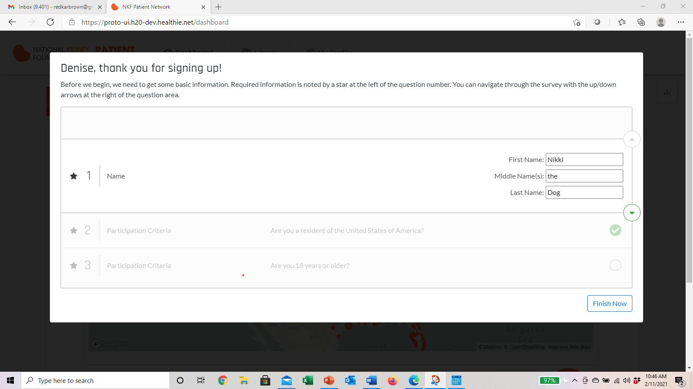
To the right of the screen there are up and down arrows to navigate through the questions.
When you have completed the questions, select FINISH NOW

This screen will appear after you select FINISH NOW. There are three (3) options-CLEAR SURVEY, REVIEW and FINISH. When you are ready to click FINISH, a message will appear to confirm your action.
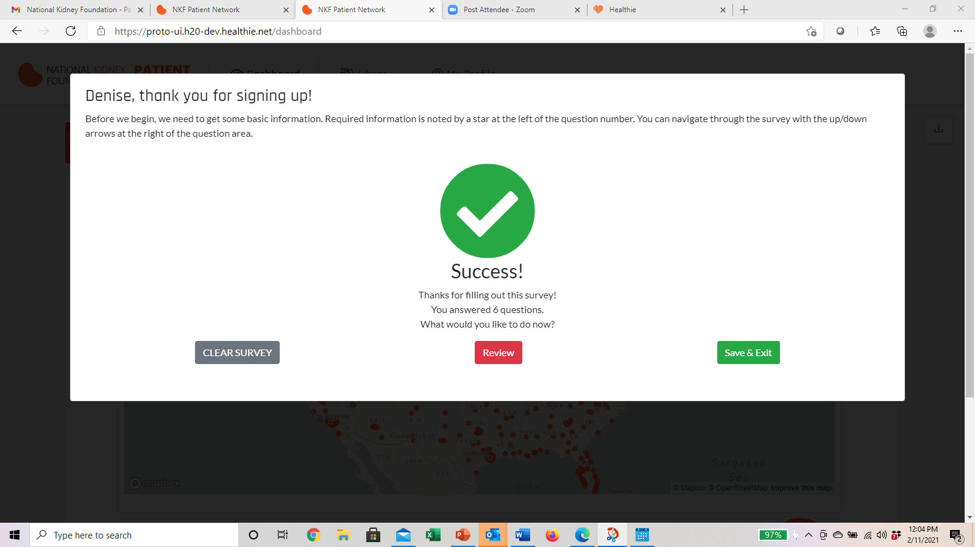
:

Dashboard

Overview
The Dashboard page will appear after you have successfully saved your basic information. Note the tabs at the top of the screen: DASHBOARD, LIBRARY and MY PROFILE. Below those tabs is the communication/message center bar which alerts you to the next step within the registry.
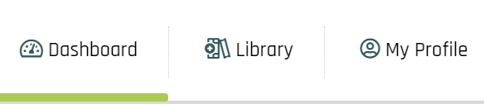

Message Center bar
On the main Dashboard screen there is the message center bar that illustrates communications regarding requested information. This will alert you to surveys which need to be completed. By selecting the GO button you will be taken to the specific survey. The right arrow button will take you to the next category of survey to complete.

SURVEYS
There is a progress bar that displays multiple sections of the survey you are completing, and the navigation arrows to the right of the panel will progress you to the next question. If at any time you would like to review a question or go back to the question you skipped, click on the navigation bar to jump to a particular question or section.
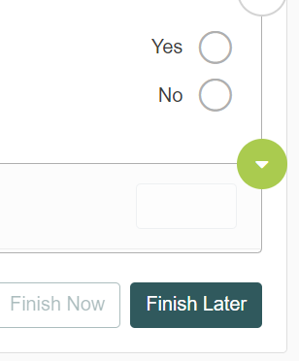
Be aware that the screens/questions are dynamic meaning that depending upon the answers you provide, there may be additional information required. Once you have completed the survey and are ready to finish, select the FINISH NOW option. When you select FINISH NOW, a Success screen appears and there are three (3) options as described in Section 4.0.
If you do not want to continue at this time, select the FINISH LATER option, which will save the information which you have entered to this point in time.
If you wish to Review your responses, click FINISH NOW and then select the REVIEW option. When reviewing your responses prior to submitting FINISH, the + icon to the left of the category list will expand your view to visualize the data which you entered. You will notice a “pencil” icon adjacent to some of the responses you provided. If you want to change the information that has a “pencil” icon, click on that icon and amend your data as appropriate. You will be taken back to the “SUCCESS” page and when you select Finish you will be returned to the main Dashboard page.

MY LIBRARY
When you access the LIBRARY tab you may select a category from the list and view the related content in that category.

MY PROFILE
When the My Profile tab is selected there is a drop-down which has My Profile, Identity Details, My Consent and Logout (your name). My Profile displays the basic information you provided after registration:

Identity Details
Under the Identity Details section from the drop-down, you may change your contact information. If the area before CONTACT Information shows a + icon, click on that to expand and display all the information in that section:

My Consent
When you select the My Consent option under the My Profile tab, you can see the Status, Consent, Consent date and VIEW option. When you select the VIEW option, you may use the scroll bar to the right of the screen to view the Consent form in its entirety. Note that at the bottom of the form is an area where you can opt to withdraw your consent.

Withdrawing Consent
When the option to Withdraw Consent is chosen this information will populate which explains what withdrawing consent means. Once you have read the information there are two (2) options: Go Back or Yes withdraw. Go Back will take you to the previous screen. NOTE: When you select “Yes withdraw” there is NO prompt to confirm your action. The “Yes withdraw” will immediately take you out of the active registry to the Log-in/Registration page.
The message below will appear if you attempt to log-in with your credentials. When you select OK you will be brought back to the Log-in/Registration screen:
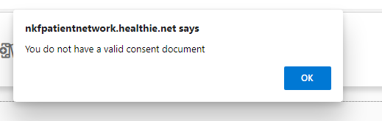
birt.healthie.net says

LOGGING OUT
By selecting LOGOUT from the drop-down option under MY PROFILE this screen will populate. As noted in the message you may return to the registry by selecting the link:

7 Help
If you are having issues with your account or you have any questions related to this research study, please select the My Consent option under the My Profile tab and click VIEW. The Consent form includes the appropriate contact information for questions related to the registry.

